*National University of Science and Technology*

**School of Mechanical and Manufacturing Engineering**

Lab Manual #09

**CS-114 Fundamentals of Programming**

**Course Instructor:** Khawaja Fahad Iqbal

**Lab Instructor:** Muhammad Affan

**Introduction:**

**Name:** Muhammad Furqan Ul Arsh

**CMS ID:** 476347

**Section:** ME-15B

**Date:** 13-12-2023

**Lab Tasks**

**Task 1:**

Make 2D Array in C++ and print left diagonal and right diagonal sum of a 3x3 matrix.

**Code:**

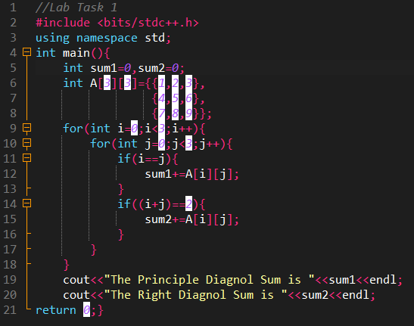

**Output:**

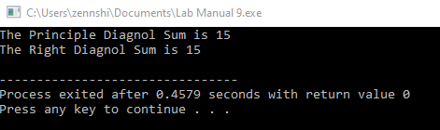

**Task 2:**

Write a function to add two 2D arrays of size 3x3.

**Code:**

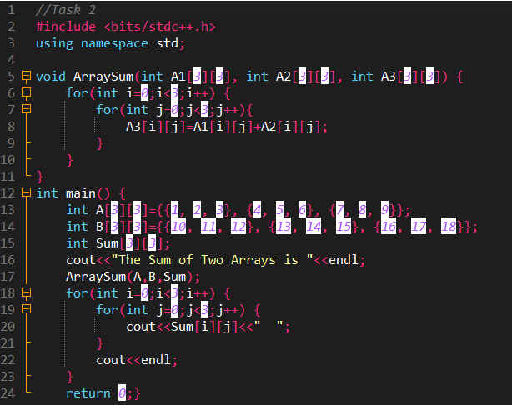

**Output:**

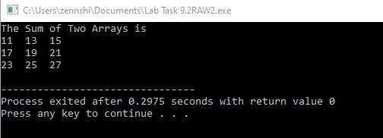

**Task 3:**

Using 2D arrays in C++, take transpose of a 3x3 matrix. Make a transpose function.

**Code:**

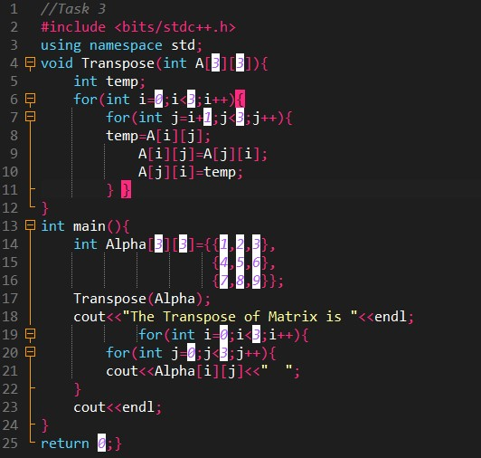

**Output:**

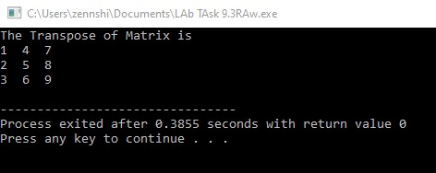

**Task 4:**

Using 2D arrays in C++, implement 3x3 matrix multiplication. Make a function.

**Code:**

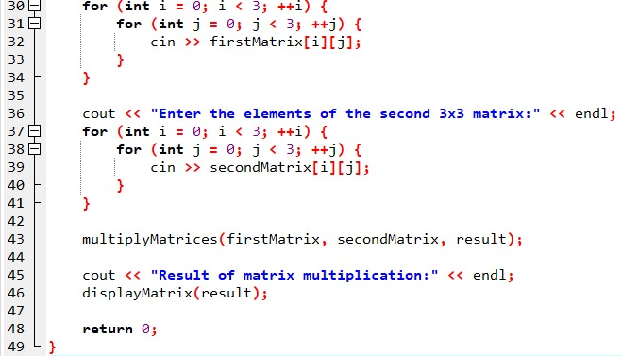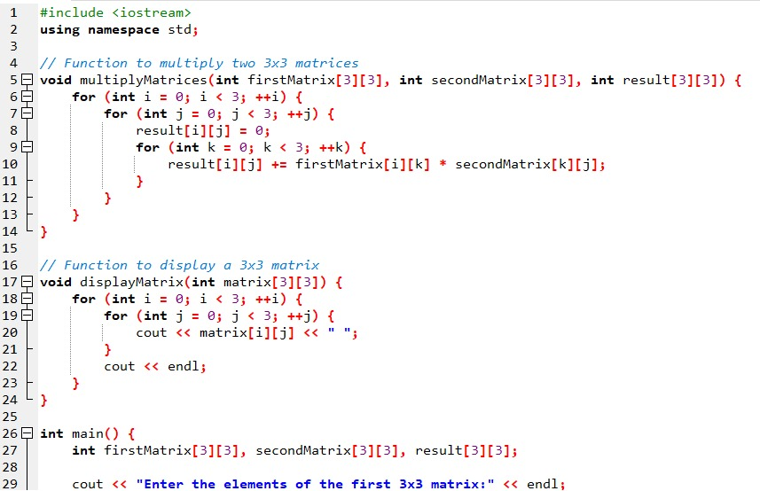

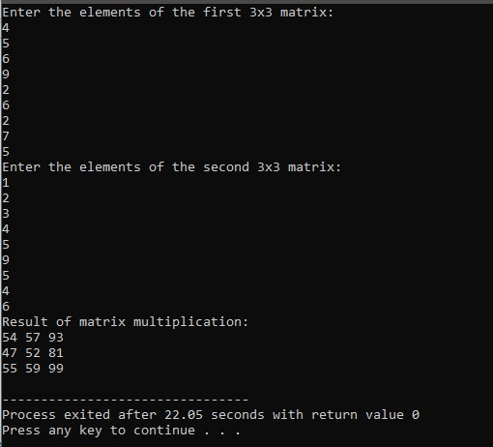**Output:**

**Task 5:**

Print the multiplication table of 15 using recursion.

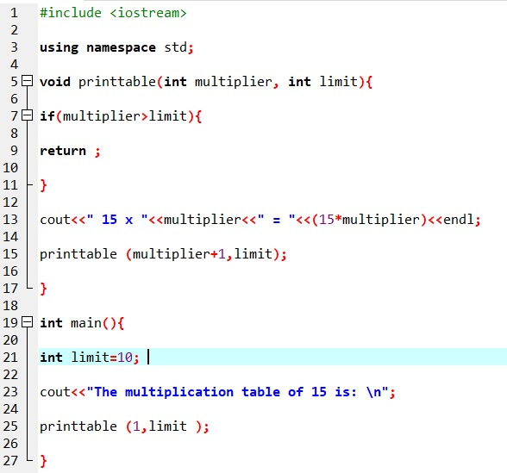**Code:**

**Output:**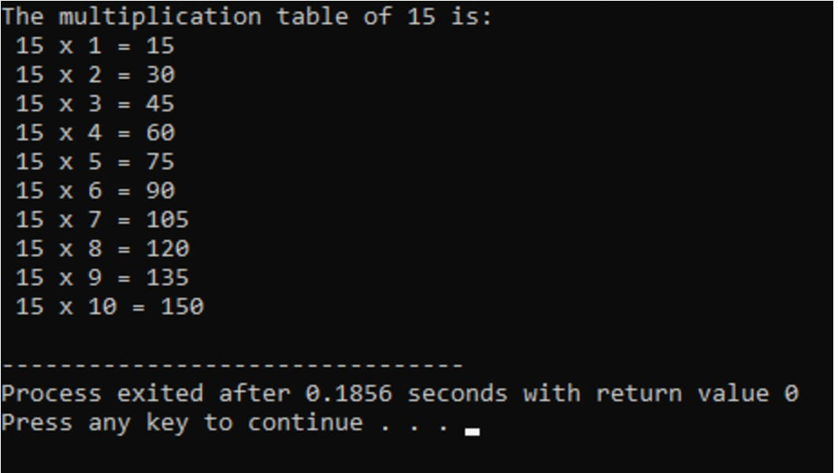

**Home Tasks**

**Task 1:**

Write a C++ program to take inverse of a 3x3 matrix using its determinant and adjoint.

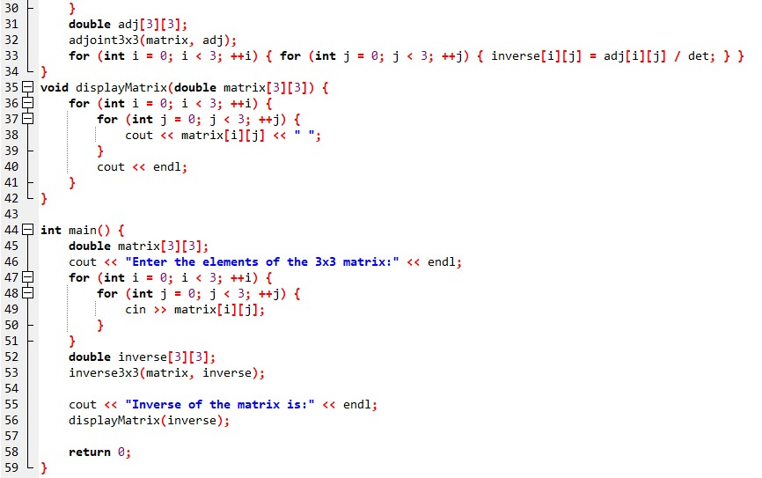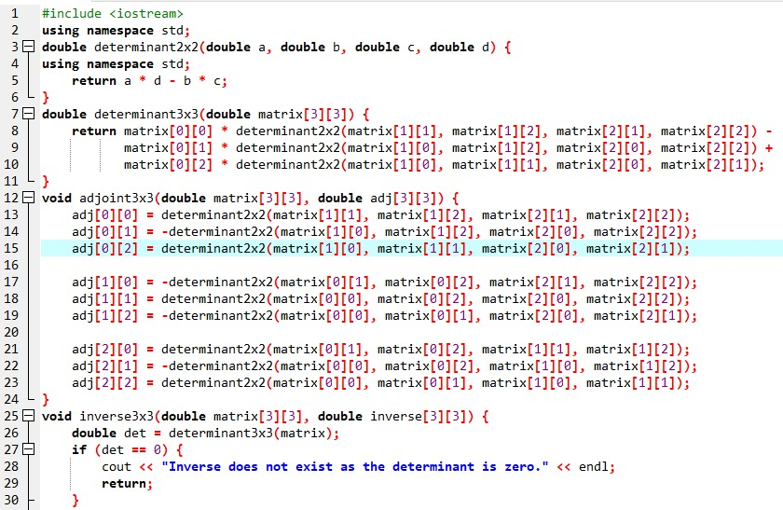**Code:**

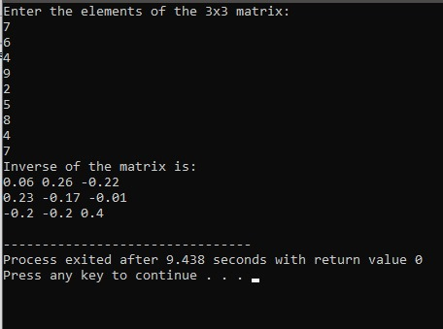**Output:**